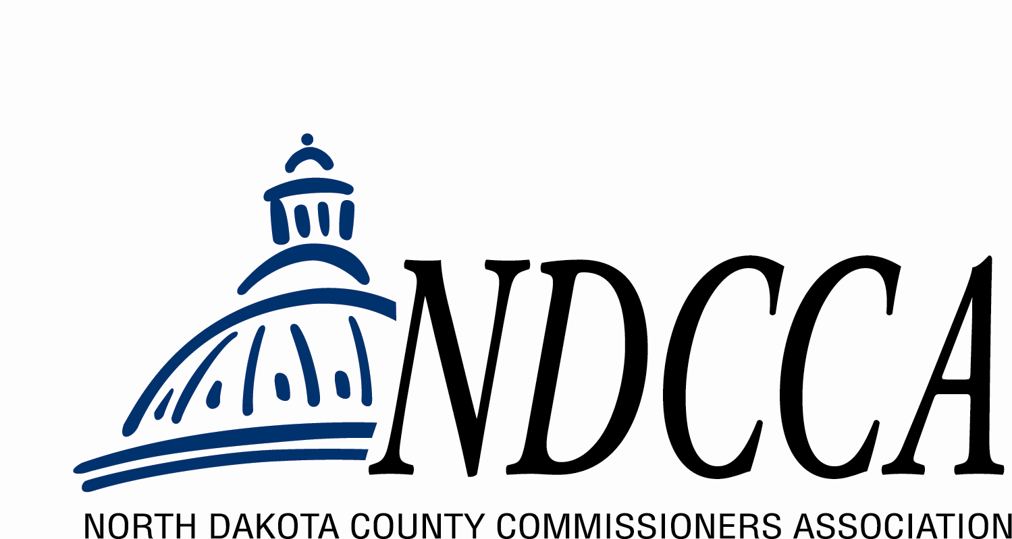
Mark Your Calendars!
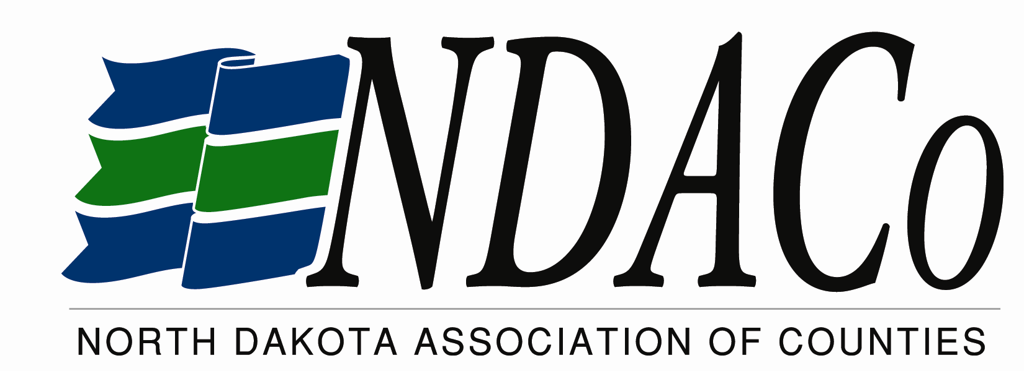

2025
County Tour
to visit
PEMBINA COUNTY

Date: Wednesday, June 11
Arrival Time: 2:00 pm CDT
Length of Visit: Up to 2 hours

The purpose of the County Tour is to increase communication
among county officials, NDACo, and NDCCA; to hear county concerns and answer any questions the county has about the services and programs the organizations provide.

NOTE: Letters regarding the visit were mailed to your commission chair & auditor. This
email notification was sent to all commissioners and department heads for whom we have an address. If we missed anyone, please notify them of this visit. Thank You!

